Methodology

1. Data Cleaning:
   * Went through the dataset in excel/python and understood the structure and various column attributes with help of data dictionary provided in the problem statement page.

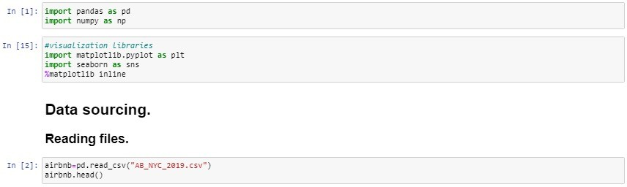

* + Checked data type of each column and converted last review column to datetime64[ns] type.

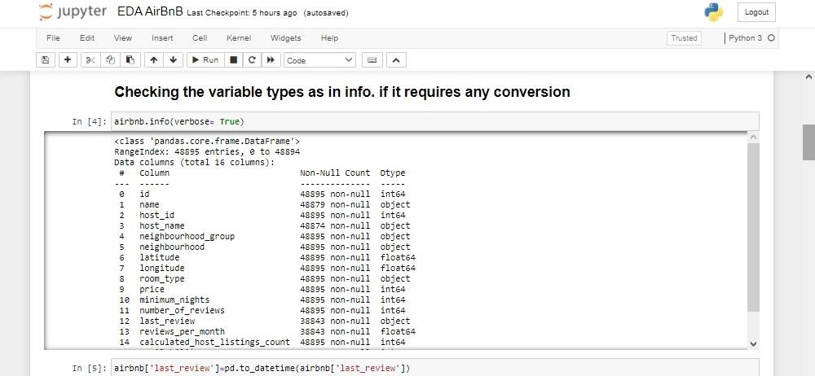

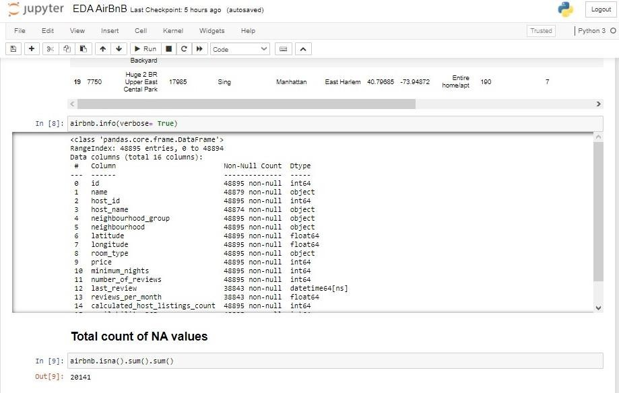

* + Checked for NA Values & replaced the same with Mode. Host Name & Name had insignificant percentage of missing values, hence we ignored the same.

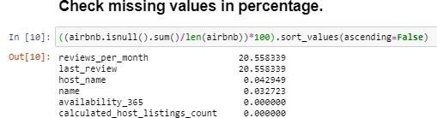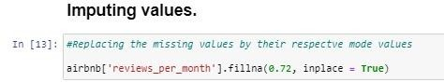

* + We did Univariate Analysis and with the help of a boxplot we found Outliers were present in the Price Column. Hence we took price as median throughout our analysis process and removed the rows which showed Price as 0.

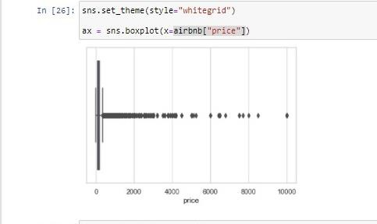

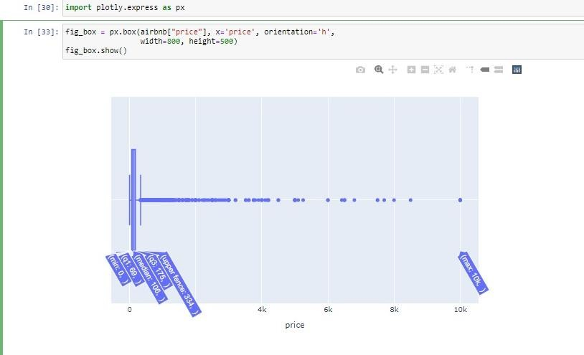



1. Exploratory Data Analysis: Listing Perspective
   * We conducted a thorough analysis of the AirBnb dataset & Identified trends and retrieved insights on Tableau to understand the next best steps to be taken post Covid-19 by AirBnb to improve the business.
   * Understanding the amount of different types of listings in different neighborhoods & their pricing structure.

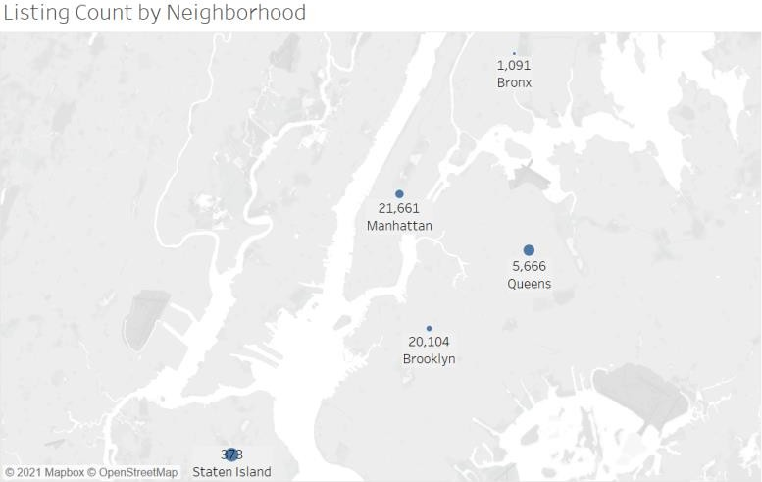

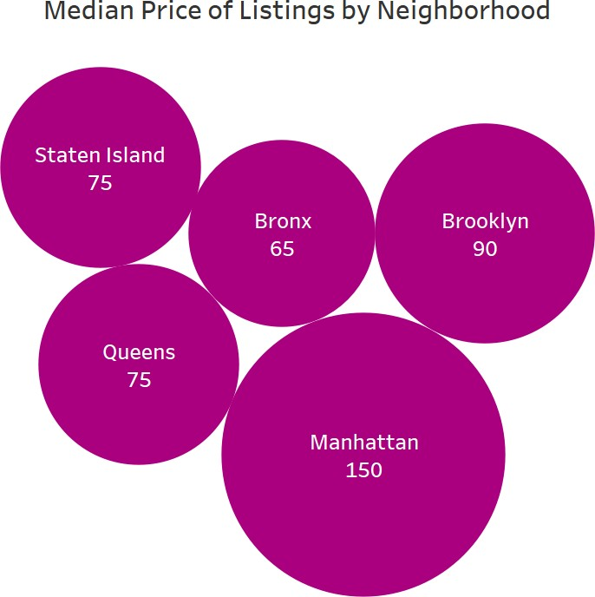

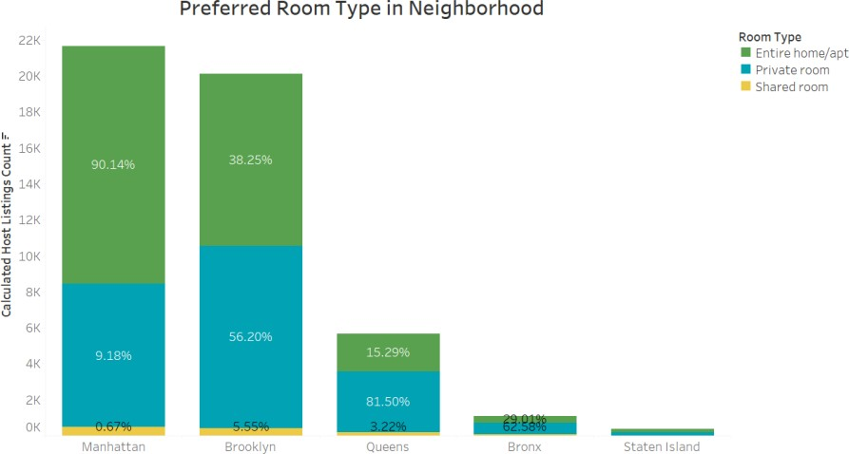

* + Checking the price range for each neighborhood according to the property type. For this we binned the prices into multiples of 1000 and found the majority listings reviewed were below $1000.

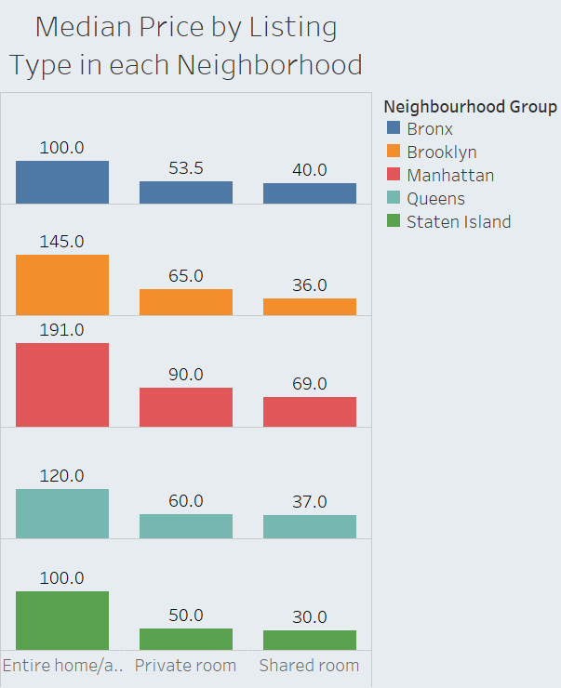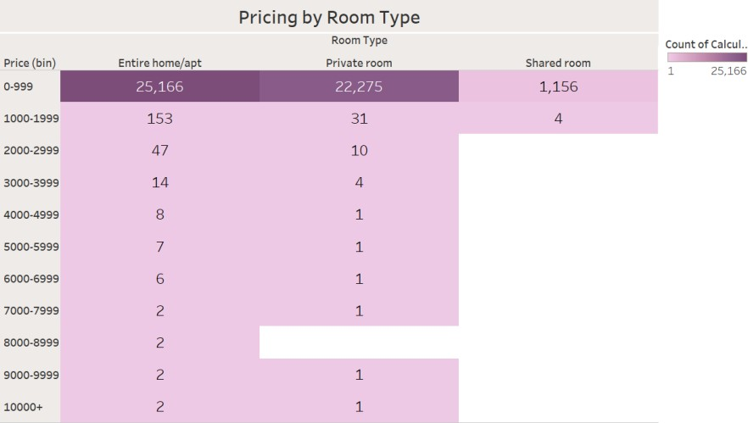

1. Exploratory Data Analysis: Customer Perspective
   * Comparing the most preferred neighborhood on pricing based on reviews

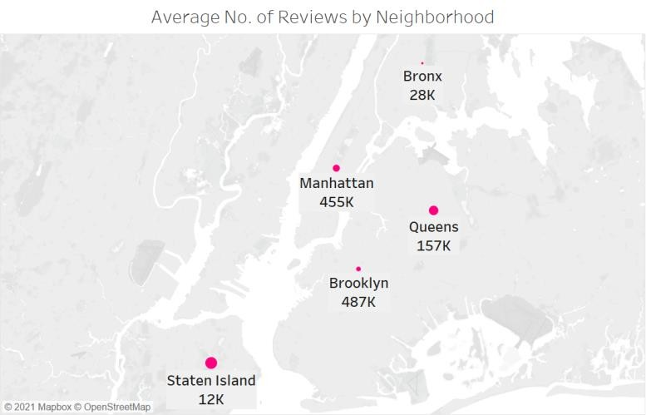

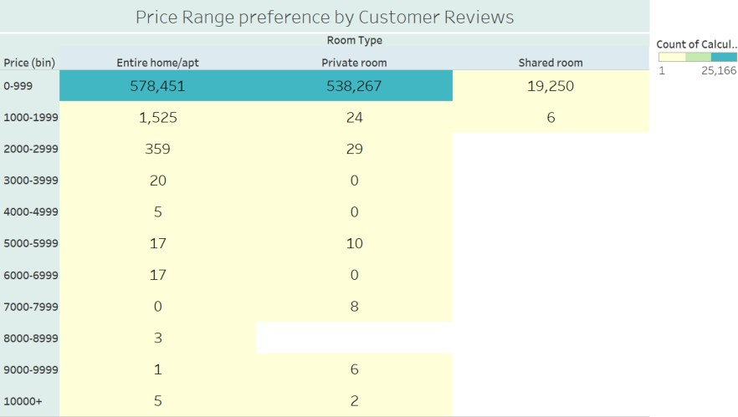

* + Understanding the customer preferences based on Minimum Nights

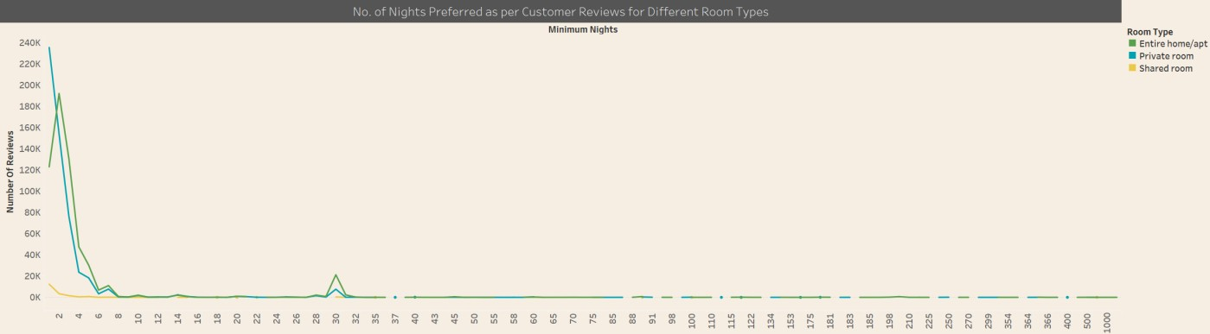

* + Checking for the top hosts and understanding the customer preferences based on what additional facilities does the host offer and the geographical location of the host which makes the listings popular.

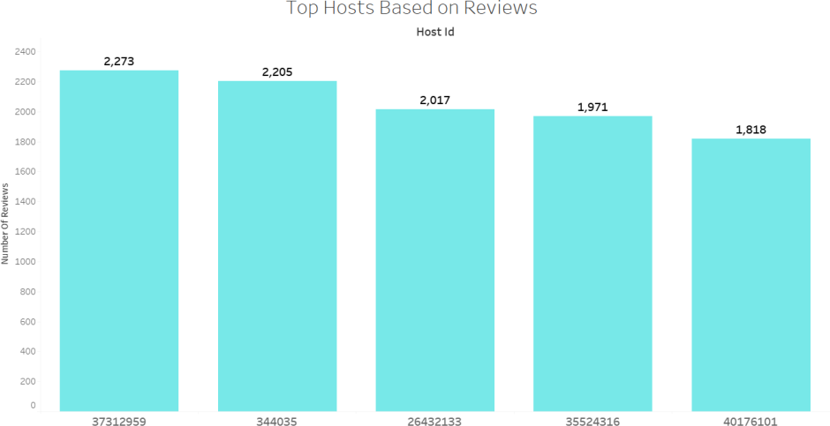

1. Final Presentation
   * The presentation includes the above structure and flow with the appropriate insights/recommendations the business has to take in order to enhance profitability post Covid-19.